Zachary Preston

Professor Kathleen Phillips

English 102 Online

28 March 2017

Argumentative Research Paper

Cover Page

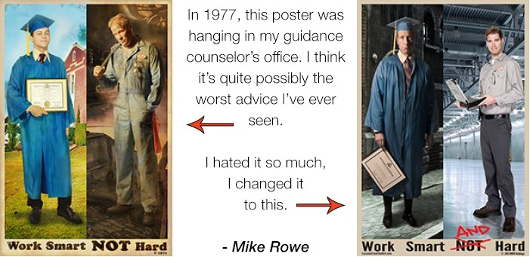 Is a college education really worth the time and money? Taken from this poster, one can see that a college education was the dream for many in 1977 and the “seemingly” uneducated when straight into a labor intensive workforce. People in technical trades today go to technical schools that train them for a certain occupation that requires both hard work and intelligence. Ever since the turn of the twentieth century, education and work has had a historical relationship (Perry 35). America is faced with plenty of educated people, but not enough jobs that require the level of education that many have obtained. The gap between business and education must be closed or as Bill Symonds, the director of Harvard University’s Pathway to Prosperity Project, puts it, “If we don’t prepare young students to succeed, the future of our country is in peril” (Kittle) Students, parents, and educators should see the need to change America’s education system to implement Project Based Learning programs in order to challenge students by a “student-driven” approach to learning (Bell 39). Although the phrase “college for all” is popular, less than a third of young people achieve the “pathway to success” (Symonds 9). Today some people continue to believe that the most successful people go to four year colleges directly out of high school; however, industry leaders are looking for employees who have hands-on technical skills that are needed to improve the industry. Every student should receive some specialized technical education while in high school before getting a bachelor’s degree to become the most successful.

At the turn of the twentieth century, schools were teaching students the basics of arithmetic, English, science, and history, also known as formal education (Perry 35). At this time, there was a need for assembly line workers so very few went to college and others took on unskilled occupations in the industry. The Smith and Hughes Act of 1917 was responsible for preparing people with vocational education to meet the needs of factories, mills, offices, and stores. Until the 1970s occupational training divided strictly academic education, wages in the labor force decreased and career education became popular. Throughout the 1980s, books such as, *America’s Choice: High Skills or Low Wages,* *A Nation at Risk*, *The Forgotten Half*, were published aimed to help prepare students for higher education. Policy makers and educators came to the conclusion that America’s education system was not preparing enough students for high-skilled, in-demand jobs. By the mid-1990s, the School-to-Work-Opportunities-Act (STWOA) of 1994, provided money to local communities to bring businesses, universities, and technical schools together to make school-based and work-based learning opportunities available to students (Perry 37). America’s educational system needs to help find students the connection between their program of study and the workplace to keep them interested in a life-long commitment to learning (Symonds 11).

In the most recent years, the Carl D. Perkins Career and Technical Education Act was reauthorized which promotes the integration of workplace experience in a classroom setting and helps fund career and technical education programs. Since the 1970s, integrating school and work has been an on-going idea. Today, career academies, starting at ninth or tenth grade, teach students around a broad career theme which include subjects in health, science, arts, and business. Technical or vocational style programs combine junior and senior year of high school with two years of community college experience for a degree or credential (Perry 38). Early college high schools provide high school students with the opportunity to gain college credit before completion of high school.